1. Explain the purpose of SQL JOIN operations. Provide examples for INNER JOIN, LEFT JOIN, and RIGHT JOIN.

ANS:

SQL JOIN operations are used to combine rows from two or more tables based on a related column between them. The purpose of JOIN operations is to retrieve data from multiple tables in a single result set. JOINs are fundamental for working with relational databases, allowing you to link data across tables and obtain meaningful information.

1. **Combine Data from Multiple Tables:**
   * SQL JOINs enable the combination of rows from different tables into a single result set. This is useful when data related to an entity is distributed across multiple tables.
2. **Retrieve Related Information:**
   * JOIN operations help retrieve related information that is stored in separate tables. For example, combining a "Customers" table with an "Orders" table allows retrieving customer information along with their order details.
3. **Avoid Data Redundancy:**
   * By distributing data across multiple tables and using JOINs, redundancy is minimized. Instead of repeating the same information in multiple tables, related data is stored in separate tables, promoting normalization.
4. **Maintain Data Integrity:**
   * SQL JOIN operations contribute to maintaining data integrity by establishing relationships between tables through foreign keys. This ensures that related data is consistent and accurate.
5. **Perform Complex Queries:**
   * JOINs enable the execution of complex queries that involve data from multiple sources. This is particularly important in scenarios where information is scattered across different tables but needs to be analyzed together.
6. **Support Business Analysis:**
   * SQL JOIN operations are essential for business analysis, reporting, and decision-making. Analysts can create comprehensive reports by combining and analyzing data from various tables.

Here are examples of three common types of SQL JOIN operations: INNER JOIN, LEFT JOIN, and RIGHT JOIN.

### 1. INNER JOIN:

The INNER JOIN keyword selects records that have matching values in both tables.

**Example:**

Consider two tables, "employees" and "departments":

```sql

SELECT employees.employee_id, employees.employee_name, departments.department_name

FROM employees

INNER JOIN departments ON employees.department_id = departments.department_id;

```

This query retrieves information about employees and their corresponding departments. It only includes rows where there is a match between the "department_id" column in the "employees" table and the "department_id" column in the "departments" table.

### 2. LEFT JOIN (or LEFT OUTER JOIN):

The LEFT JOIN keyword returns all records from the left table (table1), and the matched records from the right table (table2). The result is NULL from the right side if there is no match.

**Example:**

Using the same "employees" and "departments" tables:

```sql

SELECT employees.employee_id, employees.employee_name, departments.department_name

FROM employees

LEFT JOIN departments ON employees.department_id = departments.department_id;

```

This query retrieves all employees, including those without a matching department. If an employee doesn't have a corresponding department, the "department_name" column will contain NULL.

### 3. RIGHT JOIN (or RIGHT OUTER JOIN):

The RIGHT JOIN keyword returns all records from the right table (table2), and the matched records from the left table (table1). The result is NULL from the left side when there is no match.

**Example:**

Continuing with the "employees" and "departments" tables:

```sql

SELECT employees.employee_id, employees.employee_name, departments.department_name

FROM employees

RIGHT JOIN departments ON employees.department_id = departments.department_id;

```

This query retrieves all departments, including those without any employees. If a department doesn't have corresponding employees, the "employee_name" column will contain NULL.

In summary, SQL JOIN operations help combine data from multiple tables based on specified relationships, enabling the retrieval of more comprehensive and interconnected information. The choice between INNER, LEFT, or RIGHT JOIN depends on the desired result set and the relationships between the tables.

1. Explain the purpose of SQL JOIN operations and discuss the advantages of using them in database queries. Provide an example of an OUTER JOIN operation, along with its use case.

### Purpose of SQL JOIN Operations:

SQL JOIN operations are used to combine rows from two or more tables based on related columns. The primary purpose is to retrieve data from multiple tables in a single result set, enabling the user to work with normalized data across various tables. JOINs allow for complex queries that involve multiple tables, providing a way to link and associate data efficiently.

### Advantages of SQL JOIN Operations:

1. **Data Normalization:**

- JOINs help in maintaining normalized databases by allowing the storage of related data in separate tables. This minimizes data redundancy and ensures efficient storage.

2. **Complex Queries:**

- JOIN operations support complex queries that involve data from multiple tables. This is crucial for retrieving comprehensive information and generating insightful reports.

3. **Data Integrity:**

- By distributing related information across tables, JOINs contribute to data integrity. Foreign key relationships between tables ensure that the data remains accurate and consistent.

4. **Improved Query Performance:**

- JOINs facilitate the retrieval of data from multiple tables in a single query, reducing the need for multiple queries or post-processing of results. This can lead to improved performance.

5. **Flexibility in Data Retrieval:**

- JOINs provide flexibility in how data is retrieved. Depending on the JOIN type (INNER, LEFT, RIGHT, etc.), users can specify the relationships between tables and customize the result set.

### Example of OUTER JOIN Operation and Use Case:

An OUTER JOIN returns unmatched rows from one or both tables, filling in with NULL values where there is no match. Let's consider an example with two tables: "employees" and "departments."

Now, let's perform a LEFT OUTER JOIN to retrieve all employees and their corresponding departments, including employees without a department.

```sql

SELECT employees.employee_id, employees.employee_name, departments.department_name

FROM employees

LEFT JOIN departments ON employees.department_id = departments.department_id;

```

In this example, the LEFT OUTER JOIN ensures that all employees are included in the result, even if they don't belong to any department. The "department_name" column will contain NULL for employees without a department.

Use Case:

- This type of OUTER JOIN is useful when you want to retrieve all records from the left table (e.g., employees) and include matching records from the right table (e.g., departments). It is especially handy when dealing with scenarios where not every record in the left table has a corresponding match in the right table, and you still want to include those unmatched records in the result.

1. What is a self-join in SQL? Provide an example and describe a scenario where a self-join is useful.

**ANSWER:**

In SQL, a self-join is a specific case of a join operation where a table is joined with itself. This can be useful when you have a table with a hierarchical or recursive structure, and you need to establish relationships within the same table.

### Example of a Self-Join:

Let's consider a scenario where you have an "employees" table with a hierarchical structure, where each employee reports to another employee. The table might look like this:

```sql

CREATE TABLE employees (

employee_id INT PRIMARY KEY,

employee_name VARCHAR(50),

manager_id INT, -- Foreign key referencing employee_id in the same table

);

INSERT INTO employees VALUES (1, 'John Doe', NULL); -- CEO

INSERT INTO employees VALUES (2, 'Jane Smith', 1); -- Manager reporting to John Doe

INSERT INTO employees VALUES (3, 'Bob Johnson', 2); -- Employee reporting to Jane Smith

INSERT INTO employees VALUES (4, 'Alice Brown', 1); -- Another manager reporting to John Doe

INSERT INTO employees VALUES (5, 'Charlie Davis', 4); -- Employee reporting to Alice Brown

```

Now, if you want to retrieve information about employees and their managers, you can use a self-join:

```sql

SELECT e.employee_name AS employee, m.employee_name AS manager

FROM employees e

LEFT JOIN employees m ON e.manager_id = m.employee_id;

```

This query retrieves the names of employees along with the names of their respective managers. The self-join is performed on the "employees" table, matching the "manager_id" column with the "employee_id" column within the same table.

### Scenario where Self-Join is Useful:

A common scenario where a self-join is useful is in representing organizational hierarchies, such as reporting structures in a company. In the example above, the "employees" table represents a simple hierarchy where each employee may have a manager (except for the CEO, who has a `NULL` manager).

Another example could be representing hierarchical data in a category structure, where each category can have subcategories. In this case, the table would have a foreign key pointing to the same table to establish parent-child relationships.

### Considerations:

- When using self-joins, it's essential to use table aliases (as demonstrated in the example) to differentiate between the instances of the same table.

- Recursive queries involving self-joins may require the use of specific database features like Common Table Expressions (CTEs) in databases that support them (e.g., PostgreSQL, MySQL, SQL Server). Recursive queries are used to traverse hierarchical structures.

1. What is a self-join in SQL, and under what circumstances might you encounter a self-join in real-world databases? Provide an example of a self-join query.

**ANSWER:**

### Self-Join in SQL:

A self-join in SQL is a query where a table is joined with itself. This is useful when you want to establish relationships or retrieve information within the same table. Self-joins are commonly encountered in scenarios where hierarchical or recursive relationships exist within a dataset.

### Circumstances for Self-Join in Real-World Databases:

1. **Organizational Hierarchies:**

- In databases representing organizational structures, employees often report to other employees. A self-join can be used to retrieve information about employees and their managers.

2. **Categories and Subcategories:**

- When modeling hierarchical categories, each category may have subcategories. A self-join can help retrieve information about a category and its subcategories.

3. **Networks and Relationships:**

- In social network databases or friend relationship tables, individuals may be connected to each other. A self-join can be employed to find relationships between individuals within the same table.

4. **Bill of Materials:**

- In manufacturing databases, where products consist of subassemblies and components, a self-join can be used to represent the hierarchical structure of a bill of materials.

When you need to compare rows within the same table based on certain criteria, a self-join allows you to establish relationships between rows in a single table.

### Example of a Self-Join Query:

Let's consider an example where a company has an "employees" table with a hierarchical structure:

```sql

CREATE TABLE employees (

employee_id INT PRIMARY KEY,

employee_name VARCHAR(50),

manager_id INT, -- Foreign key referencing employee_id in the same table

);

INSERT INTO employees VALUES (1, 'John Doe', NULL); -- CEO

INSERT INTO employees VALUES (2, 'Jane Smith', 1); -- Manager reporting to John Doe

INSERT INTO employees VALUES (3, 'Bob Johnson', 2); -- Employee reporting to Jane Smith

INSERT INTO employees VALUES (4, 'Alice Brown', 1); -- Another manager reporting to John Doe

INSERT INTO employees VALUES (5, 'Charlie Davis', 4); -- Employee reporting to Alice Brown

```

Now, suppose you want to retrieve a list of employees along with their respective managers. You can use a self-join:

```sql

SELECT e.employee_name AS employee, m.employee_name AS manager

FROM employees e

LEFT JOIN employees m ON e.manager_id = m.employee_id;

```

The result of this query would be:

```

| employee | manager |

| --------------- | ------------- |

| John Doe | NULL |

| Jane Smith | John Doe |

| Bob Johnson | Jane Smith |

| Alice Brown | John Doe |

| Charlie Davis | Alice Brown |

```

In this example, the self-join helps retrieve information about employees and their managers from the same "employees" table.

1. Define the first three Normal Forms (1NF, 2NF, 3NF) in database normalization. Provide examples to illustrate each form.

**ANSWER:**

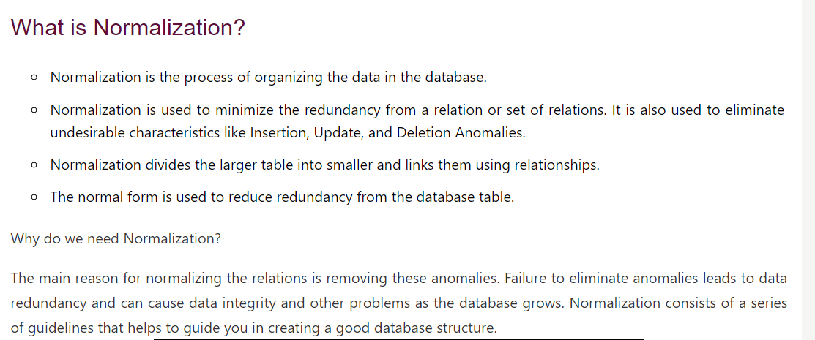

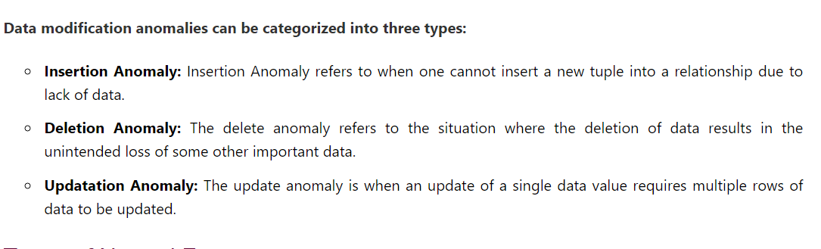

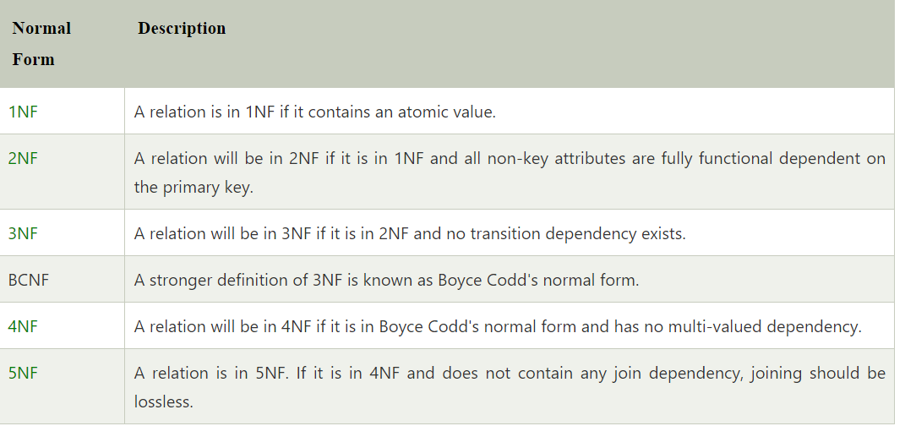

**Examples:** [**https://www.simplilearn.com/tutorials/sql-tutorial/what-is-normalization-in-sql**](https://www.simplilearn.com/tutorials/sql-tutorial/what-is-normalization-in-sql)

[**https://www.studytonight.com/dbms/database-normalization.php**](https://www.studytonight.com/dbms/database-normalization.php)

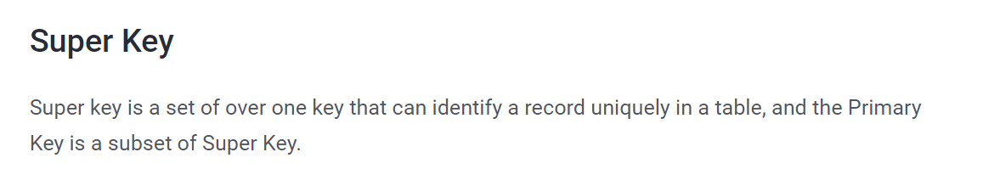

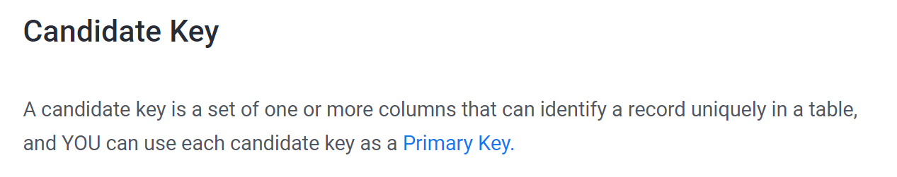

### First Normal Form (1NF):

**Definition:**

A relation is in First Normal Form (1NF) if it contains only atomic (indivisible) values, and there are no repeating groups or arrays in any column.

**Example:**

Consider a table representing student courses:

```sql

CREATE TABLE student_courses (

student_id INT PRIMARY KEY,

courses VARCHAR(50) -- Non-atomic value, violates 1NF

);

INSERT INTO student_courses VALUES (1, 'Math, Physics, Chemistry');

INSERT INTO student_courses VALUES (2, 'English, History');

```

In this example, the "courses" column violates 1NF because it contains multiple values in a single cell. To bring it into 1NF, we could create a new table:

```sql

CREATE TABLE student_courses_normalized (

student_id INT,

course_name VARCHAR(50)

);

INSERT INTO student_courses_normalized VALUES (1, 'Math');

INSERT INTO student_courses_normalized VALUES (1, 'Physics');

INSERT INTO student_courses_normalized VALUES (1, 'Chemistry');

INSERT INTO student_courses_normalized VALUES (2, 'English');

INSERT INTO student_courses_normalized VALUES (2, 'History');

```

### Second Normal Form (2NF):

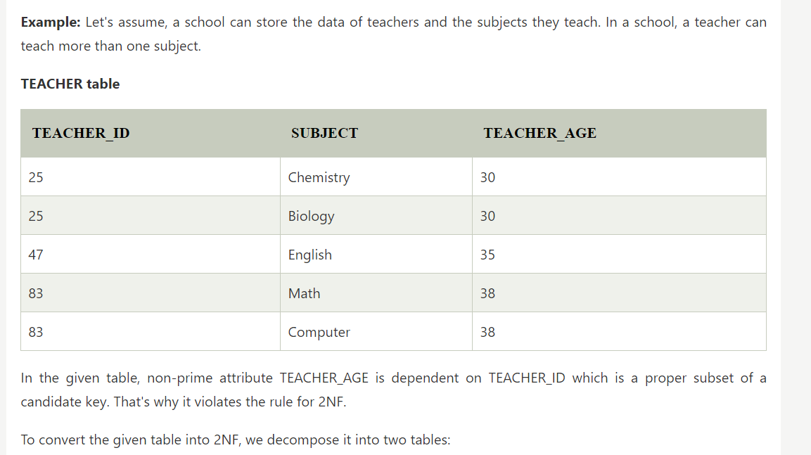

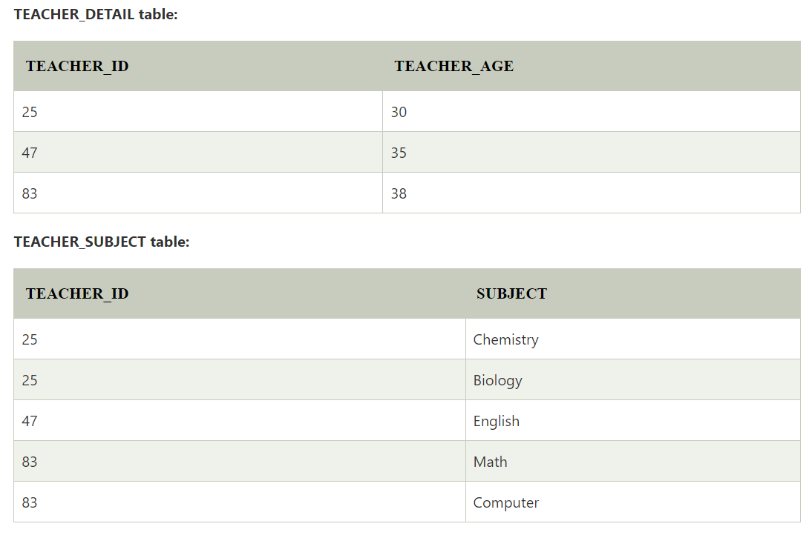

### Third Normal Form (3NF):

**Definition:**

A relation is in Third Normal Form (3NF) if it is in 2NF and there are no transitive dependencies. Non-key attributes should not depend on other non-key attributes.

**Example:**

Consider a table representing a library system:

```sql

CREATE TABLE books (

book_id INT PRIMARY KEY,

author_name VARCHAR(50),

publisher_name VARCHAR(50),

publisher_location VARCHAR(50)

);

```

In this example, "publisher_name" and "publisher_location" are transitively dependent on "author_name." To achieve 3NF, we can split the table:

```sql

CREATE TABLE authors (

author_id INT PRIMARY KEY,

author_name VARCHAR(50)

);

CREATE TABLE publishers (

publisher_id INT PRIMARY KEY,

publisher_name VARCHAR(50),

publisher_location VARCHAR(50)

);

CREATE TABLE books (

book_id INT PRIMARY KEY,

author_id INT,

publisher_id INT

);

```

In this way, we eliminate the transitive dependency between "author_name" and "publisher_name" in the original table.

1. Define the concept of the Fourth Normal Form (4NF) in the context of database normalization. Provide an example that illustrates a 4NF-compliant table.

**ANSWER:**

### Fourth Normal Form (4NF):

**Definition:**

Fourth Normal Form (4NF) is a level of database normalization that deals with multi-valued dependencies. A relation is in 4NF if it is in Third Normal Form (3NF) and has no non-trivial multi-valued dependencies.

<https://www.geeksforgeeks.org/introduction-of-4th-and-5th-normal-form-in-dbms/>



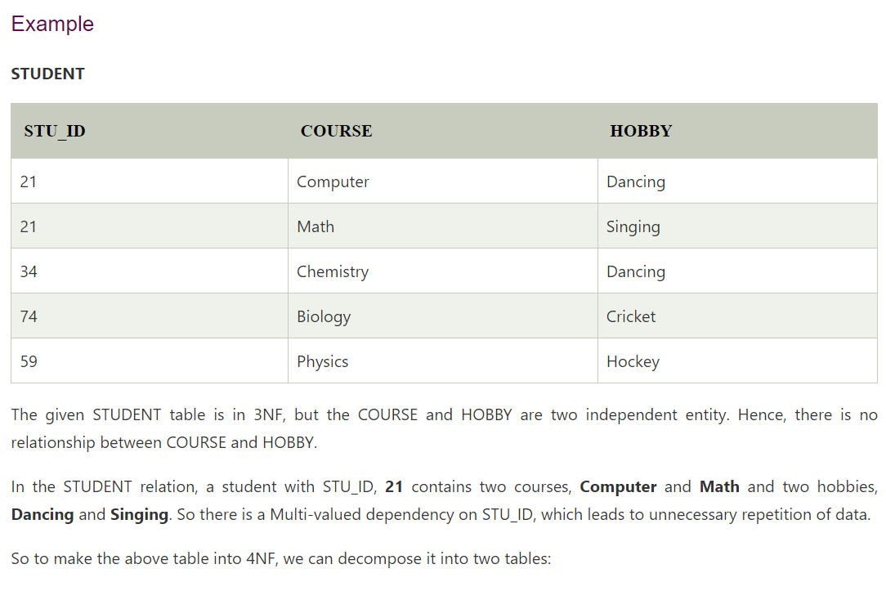

Now, the table is in 4NF. The information about courses and professors is stored in separate tables, and the "course_schedule" table represents a many-to-many relationship between courses and professors. This design eliminates the multi-valued dependency present in the original table.

1. Describe the differences between Boyce-Codd Normal Form (BCNF) and Fourth Normal Form (4NF) in the context of database design. Explain with an example.

<https://www.geeksforgeeks.org/difference-between-bcnf-and-4nf-in-dbms/>

1. What is BCNF (Boyce-Codd Normal Form), and how does it differ from 3NF? Explain with an example.

BCNF example:

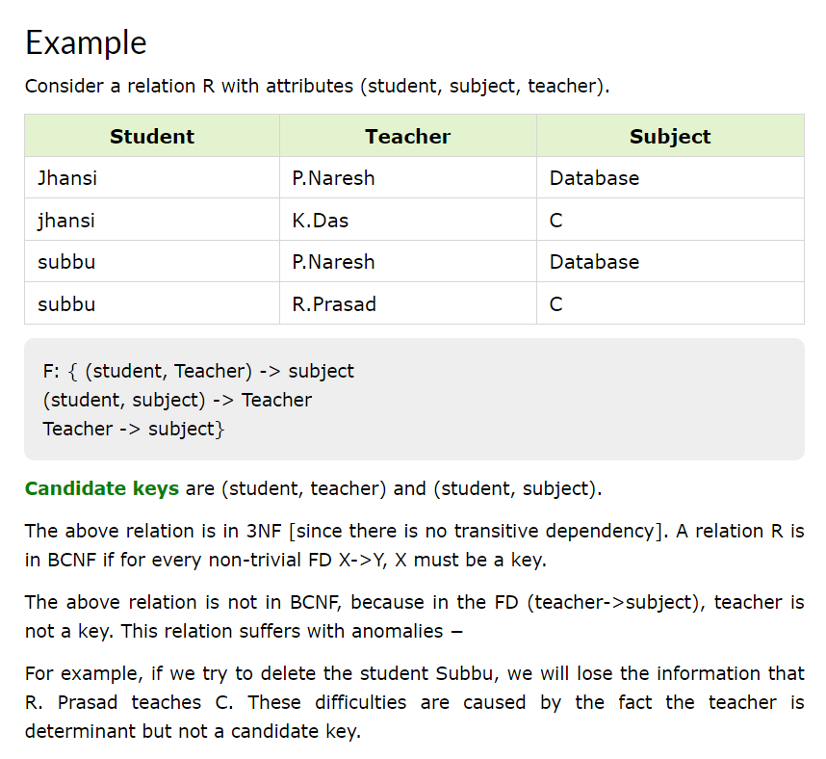

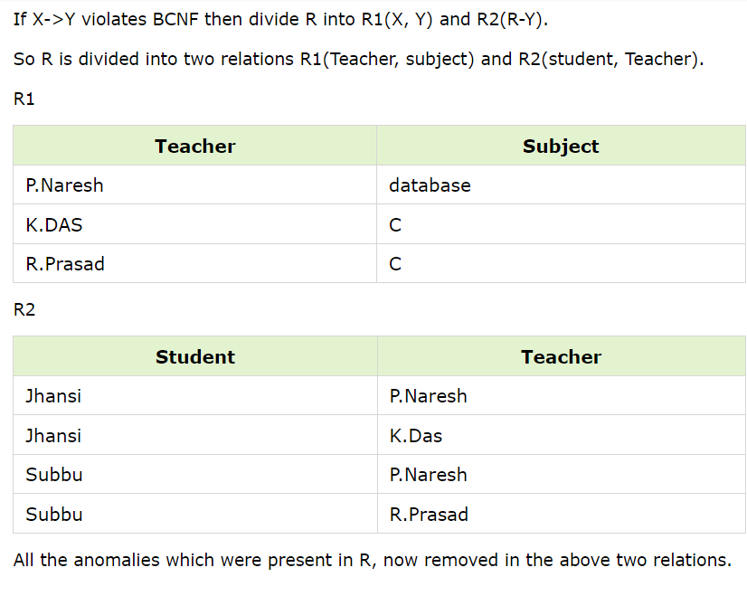

1. Discuss the importance of indexing in a database system. Explain how indexing can optimize queries, particularly for large datasets.

**Indexing in a Database:**

In a database, indexing is a technique used to enhance the speed and efficiency of data retrieval operations on tables. An index is a data structure that provides a quick reference or lookup to the rows in a table based on the values of one or more columns. It works similarly to the index in a book, allowing the database system to quickly locate the pages (rows) associated with specific keywords (column values).

### Importance of Indexing in a Database System:

**1. **Efficient Data Retrieval:**

- Indexing is crucial for quick and efficient data retrieval. Without indexes, the database system would need to scan the entire table to find the requested data, resulting in slower query performance.

**2. **Faster Query Processing:**

- Indexing significantly speeds up query processing. When a query involves conditions in the WHERE clause, indexes allow the database engine to locate the relevant rows more swiftly.

**3. **Reduced Disk I/O Operations:**

- Indexing minimizes disk I/O operations by providing a roadmap to the physical location of data on the storage device. This is particularly beneficial for large datasets where reading from disk is a time-consuming operation.

**4. **Optimized Sorting and Searching:**

- Indexes enhance sorting and searching operations. For example, if a column is indexed, sorting based on that column becomes faster because the index already contains sorted values.

**5. **Support for Unique Constraints:**

- Indexes are often used to enforce unique constraints on columns. This ensures that no two rows in a table can have the same values for the indexed column(s), enhancing data integrity.

**6. **Accelerated Joins:**

- When performing join operations, indexes on the join columns can significantly speed up the process. The database engine can use indexes to locate matching rows in the joined tables more efficiently.

**7. **Enhanced Performance for Aggregations:**

- Indexes are beneficial for aggregation functions such as COUNT, AVG, SUM, etc. They help the database engine quickly locate the necessary rows, reducing the time needed to perform aggregations.

**8. **Improved Concurrency:**

- Indexes can improve the concurrency of a database system. Multiple users can simultaneously execute queries on the same dataset more efficiently when indexes are in place.

**9. **Query Plan Optimization:**

- The database query planner can use indexes to generate optimized query plans. This involves choosing the most efficient route to retrieve data based on the available indexes.

**10. **Efficient Range Queries:**

- For range queries (e.g., WHERE salary > 50000), indexes allow the database engine to quickly identify and retrieve the rows that satisfy the specified range condition.

**Conclusion:**

Indexing is a critical aspect of database optimization, especially in scenarios where datasets are large or queries are complex. Well-designed indexes can significantly enhance the speed and efficiency of data retrieval and manipulation operations. However, it's essential to strike a balance between the benefits of indexing and the costs associated with maintaining indexes during data modifications (inserts, updates, and deletes).

1. Describe what an index is in the context of a database. How does indexing improve query performance?

**ANSWER; SAME AS ABOVE**

1. Explain the differences between a unique index and a unique constraint in a relational database. Provide an example for each.

**ANSWER:**

### Unique Index vs. Unique Constraint in a Relational Database:

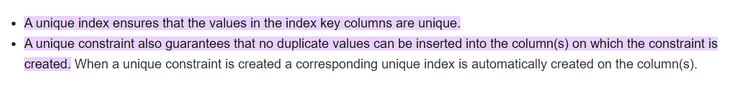

**1. Unique Index:**

- **Definition:**

- A unique index is an index on one or more columns of a table that enforces the uniqueness of values in those columns. It allows for fast lookup of rows based on the indexed columns and ensures that no two rows in the table can have the same combination of values in the indexed columns.

- **Example SQL Syntax:**

```sql

CREATE UNIQUE INDEX index_name ON table_name (column1, column2);

```

- **Example Use Case:**

- Suppose you have a table named `employees` with columns `employee_id` and `email`. To ensure that each employee has a unique email address, you can create a unique index on the `email` column:

```sql

CREATE UNIQUE INDEX idx_unique_email ON employees (email);

```

**2. Unique Constraint:**

- **Definition:**

- A unique constraint is a rule applied to one or more columns of a table that ensures the uniqueness of values in those columns. It can be applied when defining the table structure and serves the same purpose as a unique index by preventing duplicate values.

- **Example SQL Syntax:**

```sql

ALTER TABLE table_name

ADD CONSTRAINT constraint_name UNIQUE (column1, column2);

```

- **Example Use Case:**

- Using the same `employees` table example, you can enforce uniqueness on the `email` column using a unique constraint:

```sql

ALTER TABLE employees

ADD CONSTRAINT uq_unique_email UNIQUE (email);

```

### Key Differences:

1. **Implementation:**

- A unique index is a separate data structure associated with the table, providing a fast lookup mechanism for unique values.

- A unique constraint is a rule enforced directly on the table columns, ensuring uniqueness during data insertion or modification.

2. **Syntax:**

- Creating a unique index involves using the `CREATE UNIQUE INDEX` statement.

- Adding a unique constraint is done with the `ALTER TABLE ADD CONSTRAINT` statement.

3. **Purpose:**

- Both a unique index and a unique constraint serve the purpose of enforcing uniqueness in specified columns, preventing the insertion of duplicate values.

4. **Additional Functionality:**

- A unique index, being a separate structure, can be dropped or modified independently of other constraints.

- A unique constraint is part of the table definition and is managed along with other constraints.

5. **Implicit Index Creation:**

- In many relational database systems, creating a unique constraint automatically creates a unique index to support the constraint.

In practice, the choice between a unique index and a unique constraint may depend on specific database management system features and the overall design preferences of the database administrator. In many cases, creating a unique constraint implicitly creates a unique index to enforce uniqueness efficiently.

1. Explain the differences between clustered and non-clustered indexes in a database. Provide examples of situations where each type is beneficial?

**ANSWER:**

### Clustered Index vs. Non-Clustered Index:

**1. Clustered Index:**

- **Definition:**

- A clustered index determines the physical order of the rows in a table based on the indexed column(s). In other words, the rows in the table are stored on disk in the same order as the clustered index. Each table can have only one clustered index.

In simple words, a clustered index in a database is a way of organizing the data in a table based on the order of the index key. Unlike a non-clustered index, a clustered index determines the physical order of rows in the table.

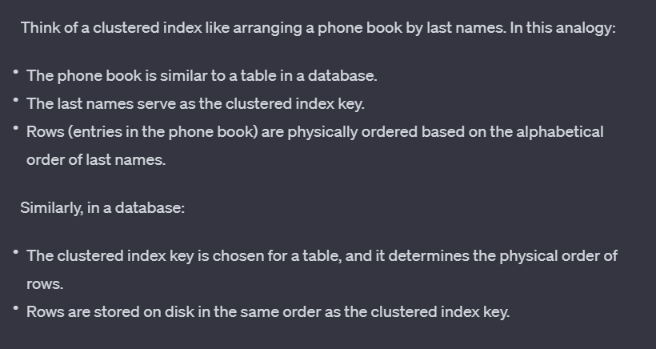

- **Example SQL Syntax:**

```sql

CREATE CLUSTERED INDEX idx_clustered_column ON table_name (column1);

```

- **Benefits:**

Advantages of a Clustered Index:

1. **Improved Query Performance:** Because rows are physically organized based on the index key, queries that involve range scans or searches using that key can be more efficient.
2. **Sequential Access:** When data is stored sequentially on disk, it can lead to faster sequential access patterns, beneficial for certain types of queries.
3. **Reduced I/O Operations:** Since related rows are stored together, the number of I/O operations needed for certain queries can be minimized.
4. Faster retrieval of range-based queries.
5. Improved performance for certain types of queries, especially those involving range scans or sequential access.

- **Example Use Case:**

- Consider a table named `Orders` with a clustered index on the `OrderDate` column. This can benefit queries that retrieve orders within a specific date range.

```sql

CREATE CLUSTERED INDEX idx_clustered_orderdate ON Orders (OrderDate);

```

**2. Non-Clustered Index:**

- **Definition:**

- A non-clustered index does not affect the physical order of the rows in the table. Instead, it creates a separate structure that includes a sorted list of index key values and pointers to the corresponding rows. A table can have multiple non-clustered indexes.

In simple terms, a non-clustered index in a database is like an additional list of information that helps you quickly find specific rows in a table. Unlike a clustered index, a non-clustered index doesn't dictate the physical order of rows in the table; instead, it creates a separate structure to speed up searches.

Think of a non-clustered index like an index at the end of a book. In this analogy:

* The book represents a table in a database.
* The index at the end of the book is similar to a non-clustered index.
* The index lists important keywords (index key) along with page numbers where you can find information about those keywords.

- **Example SQL Syntax:**

```sql

CREATE NONCLUSTERED INDEX idx_nonclustered_column ON table_name (column1);

```

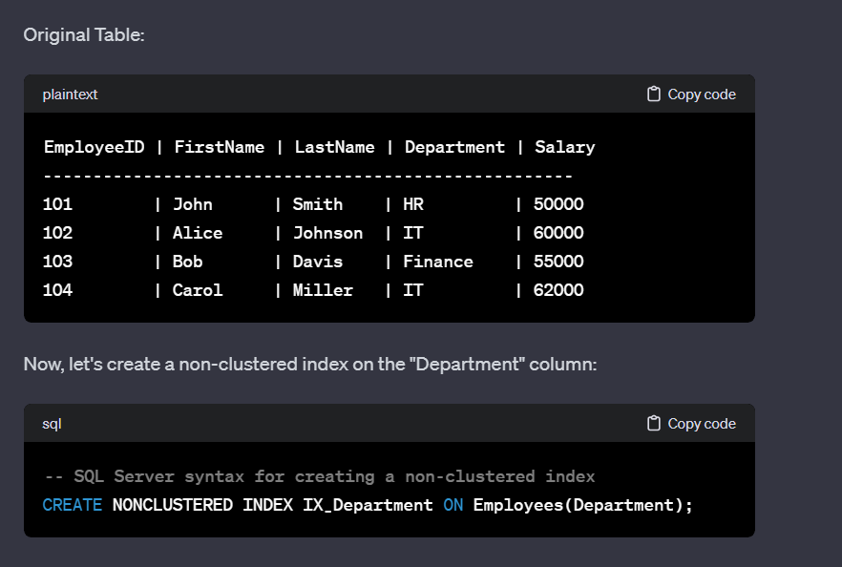

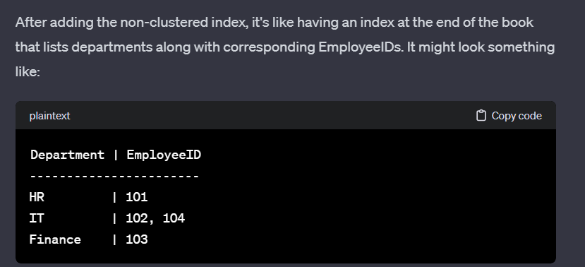

- **Benefits:**

- Efficient for columns frequently used in search conditions.

- Allows the creation of multiple indexes on a table without affecting the physical order of the data.

1. **Improved Query Performance:** Non-clustered indexes significantly enhance the speed of query execution. When searching for specific values or ranges in columns covered by non-clustered indexes, the database engine can quickly locate the relevant rows without scanning the entire table.
2. **Efficient Sorting and Filtering:** Non-clustered indexes provide efficient sorting and filtering capabilities for queries. This is particularly beneficial when dealing with ORDER BY and WHERE clauses, as the database engine can leverage the index to avoid sorting the entire dataset.
3. **Reduced I/O Operations:** Non-clustered indexes reduce the number of I/O operations needed to retrieve data, leading to better overall performance. Instead of scanning the entire table, the engine can follow the index structure to locate specific rows.
4. **Support for Multiple Indexes:** Unlike clustered indexes, a table can have multiple non-clustered indexes. This allows optimization for different query patterns, accommodating various search and retrieval scenarios.
5. **Concurrency:** Non-clustered indexes can improve concurrency by reducing the time locks are held during data modifications (INSERT, UPDATE, DELETE operations). This is because the engine needs to update fewer index pages compared to a clustered index.
6. **Flexibility in Index Composition:** Non-clustered indexes provide flexibility in choosing index key columns. Database administrators can carefully select columns that align with common query patterns, making it possible to create indexes tailored to specific use cases.
7. **Support for Unique Constraints:** Non-clustered indexes can enforce unique constraints on columns, ensuring that no two rows have the same values in the indexed columns.
8. **Storage Efficiency:** Non-clustered indexes consume less storage space compared to clustered indexes because they don't dictate the physical order of data on disk. This makes them suitable for columns with a high degree of duplication.

- **Example Use Case:**

- Suppose you have a table named `Employees` with a non-clustered index on the `LastName` column. This can benefit queries that search for employees by their last names.

```sql

CREATE NONCLUSTERED INDEX idx_nonclustered_lastname ON Employees (LastName);

```

### Key Differences:

1. **Physical Order:**

- Clustered Index: Dictates the physical order of rows in the table.

- Non-Clustered Index: Does not impact the physical order; maintains a separate structure.

2. **Number of Indexes:**

- Clustered Index: Only one per table.

- Non-Clustered Index: Multiple indexes can be created on a table.

3. **Data Modification Overhead:**

- Clustered Index: Data modification operations (e.g., inserts, updates, deletes) can be more resource-intensive because they may require rearranging the physical order of rows.

- Non-Clustered Index: Data modification operations are generally less resource-intensive, as they don't affect the physical order of data.

4. **Use Cases:**

- Clustered Index: Well-suited for range-based queries or when data retrieval follows a specific order.

- Non-Clustered Index: Effective for columns frequently used in search conditions or when multiple indexes are needed.

5. **Storage Considerations:**

- Clustered Index: Requires more storage space, as the data is physically ordered.

- Non-Clustered Index: Requires additional storage for the index structure but doesn't impact the physical order of data.

In summary, the choice between a clustered and non-clustered index depends on the specific requirements of the database and the types of queries frequently executed. Clustered indexes are beneficial for certain types of queries, while non-clustered indexes provide flexibility and efficiency for search conditions.

1. What is the role of stored procedures in SQL, and how do they enhance the maintainability and security of database operations?

**ANSWER:**

### Role of Stored Procedures in SQL:

**1. Definition:**

- A stored procedure in SQL is a precompiled collection of one or more SQL statements that can be executed as a single unit. It is stored in the database and can be called by name to perform a specific task or set of tasks.

create a stored procedure to retrieve employee information based on their department.

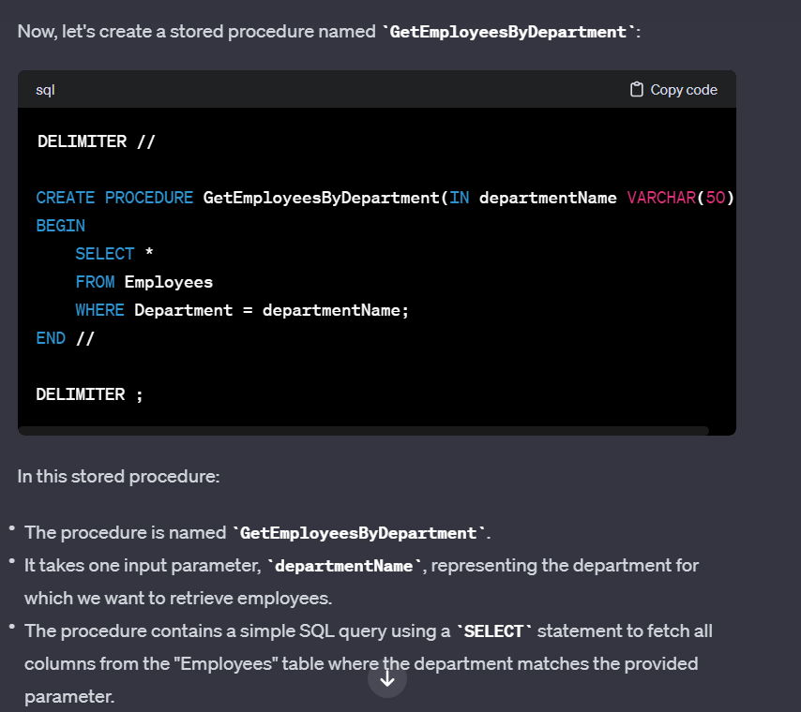

**2. Key Aspects:**

- **Parameters:** Stored procedures can accept parameters, allowing them to be dynamic and reusable for different inputs.

- **Transaction Control:** They can include transaction management statements (e.g., BEGIN TRANSACTION, COMMIT, ROLLBACK) to ensure data integrity.

- **Flow Control:** Stored procedures can include conditional statements, loops, and error handling for robust control flow.

**3. Enhancements to Maintainability:**

- **Code Reusability:** Stored procedures promote code reusability. A single stored procedure can be called from various parts of an application or multiple applications, reducing code duplication.

- **Centralized Maintenance:** As stored procedures are stored in the database, changes or updates to procedures can be done centrally. This ensures that all applications using the stored procedures automatically benefit from the changes.

- **Ease of Debugging:** Debugging is simplified as stored procedures can be tested and debugged independently of the application code. This separation of concerns makes troubleshooting more efficient.

**4. Enhancements to Security:**

- **Access Control:** Users can be granted execute permissions on stored procedures without providing direct access to underlying tables. This restricts users to executing predefined operations without exposing the underlying data structure.

- **Parameterized Queries:** The use of parameterized queries in stored procedures helps prevent SQL injection attacks. Parameters are treated as data rather than executable code, reducing the risk of malicious input.

- **Reduced Network Traffic:** Executing a stored procedure involves sending only the procedure name and parameter values over the network, rather than the entire SQL code. This reduces the risk of eavesdropping on sensitive SQL statements.

- **Encapsulation of Logic:** Stored procedures encapsulate business logic within the database, allowing administrators to control who can execute specific operations. This enhances security by limiting direct access to tables.

**5. Performance Benefits:**

- **Query Plan Caching:** Database systems can cache the execution plan of stored procedures, leading to improved performance on subsequent executions.

- **Reduced Network Latency:** Since the logic is stored in the database, there is less need to send large volumes of data between the application and the database, reducing network latency.

- **Optimized Execution:** Stored procedures are precompiled and optimized, which can result in faster execution compared to ad-hoc queries.

### Summary:

Stored procedures play a crucial role in SQL by providing a means to encapsulate and execute logic within the database. They enhance maintainability by promoting code reuse, centralizing maintenance, and simplifying debugging. Additionally, stored procedures contribute to security by controlling access, preventing SQL injection, and encapsulating business logic. Their performance benefits include query plan caching and optimized execution. Overall, stored procedures are a powerful feature that contributes to the efficiency, security, and maintainability of database operations.

1. Define stored procedures in SQL. How are they useful in database management systems?

**ANSWERS:**

Stored procedures in SQL are named sets of SQL statements that can be executed with a single command. They are precompiled and stored in the database for reuse. Stored procedures offer several benefits in database management systems:

1. Modularization: Stored procedures allow you to modularize your SQL code. Instead of writing the same SQL logic in multiple places in your application, you can encapsulate it in a stored procedure and call the procedure whenever needed. This promotes code reusability and maintainability.
2. Improved Performance: Stored procedures are precompiled and optimized, which can lead to improved performance. When a stored procedure is executed, the database engine doesn't need to reparse and recompile the SQL statements, resulting in faster execution times, especially for frequently executed operations.
3. Security: Stored procedures provide a level of security by allowing you to control access to the underlying tables. Users and applications can be granted permission to execute a stored procedure without direct access to the tables, reducing the risk of unauthorized data modifications.
4. Reduced Network Traffic: Executing a stored procedure involves sending a single command from the client to the database server, reducing the amount of data transferred over the network. This is beneficial for applications with a client-server architecture.
5. Transaction Control: Stored procedures can include multiple SQL statements, and you can control transactions within a stored procedure. This ensures that a series of related operations either succeed or fail as a unit.
6. Ease of Maintenance: Changes to the database logic can be implemented in a single stored procedure, avoiding the need to update the logic in multiple places in your application. This makes maintenance tasks more straightforward and less error-prone.
7. Encapsulation of Business Logic: Business logic related to data processing can be encapsulated within stored procedures. This separation of concerns makes it easier to manage and update the business rules without affecting the application code.
8. Parameterized Input: Stored procedures can accept parameters, allowing for dynamic data processing. This flexibility enables you to reuse the same procedure with different input values.
9. Define a database trigger and elaborate on its various applications, including auditing and data validation. Provide a scenario where a trigger is essential.

**ANSWER:**

A database trigger is a set of instructions that are automatically executed, or "triggered," in response to specific events on a particular table or view in a database. Triggers are often used to enforce business rules, maintain data integrity, and automate actions in response to changes in the database.

**Structure of a Trigger:** A trigger typically consists of three main components:

1. **Event:** The event that causes the trigger to be executed. Common events include INSERT, UPDATE, DELETE, or a combination of these.
2. **Condition (Optional):** An optional condition or predicate that specifies when the trigger should be fired. If the condition is not met, the trigger won't execute.
3. **Action:** The set of SQL statements or procedures that are executed when the trigger is fired. This is the code that performs the desired action in response to the triggering event.

Here's a simple example of a trigger in MySQL that ensures the salary of an employee is not updated to a value less than the current salary:

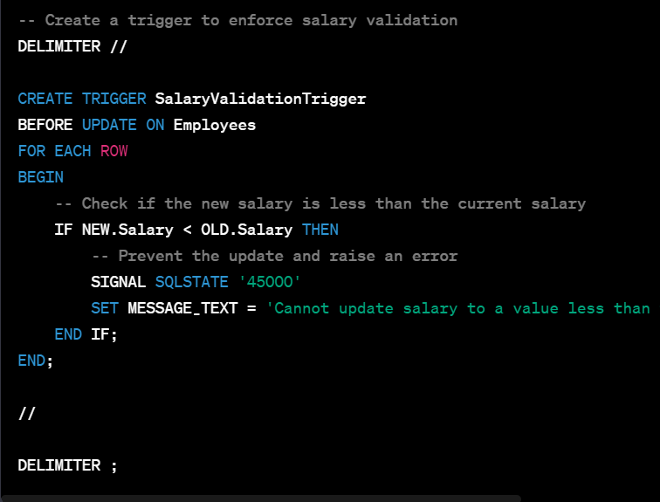

**Applications of Database Triggers:**

1. **Data Validation:**
   * *Scenario:* Suppose you have a table storing employee information, and you want to ensure that the salary of an employee is not updated to a value less than the current salary. You can use a trigger to validate this condition before allowing the UPDATE operation.
2. **Audit Logging:**
   * *Scenario:* To maintain an audit trail of changes to sensitive data, you can use triggers to automatically log information such as who made the change, what was changed, and when it occurred. This is crucial for tracking and auditing purposes.
3. **Enforcing Referential Integrity:**
   * *Scenario:* When records in a child table are linked to records in a parent table, triggers can be used to enforce referential integrity by preventing the deletion of a parent record if related child records exist.
4. **Automated Updates:**
   * *Scenario:* If you have denormalized data or calculated fields that need to be updated automatically when certain conditions change, triggers can be used to perform these updates seamlessly.
5. **Preventing Invalid Transactions:**
   * *Scenario:* Imagine a scenario where a business rule dictates that an order cannot be shipped if the corresponding products are not in stock. A trigger can be employed to prevent the INSERT or UPDATE of an order that violates this rule.
6. **Complex Default Values:**
   * *Scenario:* When default values for a column are determined by complex business rules or conditions, triggers can be used to calculate and set these values based on the context of the insertion.
7. What is a database trigger, and how can it be used to enforce data integrity and automate actions in a database?

**ANSWER:**

Triggers can be used to enforce data integrity and automate actions in a database by responding to specific events and executing predefined actions. Here's how triggers contribute to these aspects:

**Enforcing Data Integrity:**

1. **Primary Key and Unique Constraints:**
   * **Scenario:** Ensuring unique values in a column.
   * **Trigger Use:** Before an INSERT or UPDATE operation, a trigger can check if the proposed value violates the primary key or unique constraints and reject the operation if needed.
2. **Referential Integrity:**
   * **Scenario:** Preventing the deletion of a record with dependent child records.
   * **Trigger Use:** Before a DELETE operation, a trigger can check if there are dependent records in child tables and prevent the deletion if the referential integrity is violated.
3. **Check Constraints:**
   * **Scenario:** Verifying that values in a column meet specific criteria.
   * **Trigger Use:** Before an INSERT or UPDATE operation, a trigger can validate values against predefined criteria using conditional statements.

**Automating Actions:**

1. **Audit Logging:**
   * **Scenario:** Tracking changes made to sensitive data.
   * **Trigger Use:** After INSERT, UPDATE, or DELETE operations, a trigger can log relevant details (e.g., user, timestamp, action) in an audit table for auditing purposes.
2. **Automated Updates:**
   * **Scenario:** Keeping denormalized data consistent.
   * **Trigger Use:** After relevant operations, a trigger can automatically update related data in other tables to maintain consistency.
3. **Complex Default Values:**
   * **Scenario:** Setting default values based on business rules.
   * **Trigger Use:** Before an INSERT operation, a trigger can calculate and set default values for certain columns based on business rules.
4. **Notification or Alerts:**
   * **Scenario:** Notifying stakeholders about specific changes.
   * **Trigger Use:** After critical operations, a trigger can send notifications or trigger alert mechanisms to inform relevant parties.
5. **Derived Data:**
   * **Scenario:** Calculating and maintaining derived values.
   * **Trigger Use:** After relevant operations, a trigger can compute and update derived values based on predefined formulas or calculations.
6. **Business Rules Enforcement:**
   * **Scenario:** Enforcing specific business rules or policies.
   * **Trigger Use:** Before or after operations, triggers can implement checks and actions to enforce business rules defined for the database.

**Example:**

Consider a scenario where an online store wants to enforce inventory management:

* **Data Integrity:** Triggers can ensure that product quantities in the "Products" table never go below zero, preventing overselling.
* **Automated Actions:** Triggers can automatically update the total sales or send restocking alerts when certain thresholds are reached.

1. Describe the concept of a materialized view in a database, and explain the advantages of using them. Provide a real-world scenario where a materialized view can significantly improve query performance.

**ANSWERS:**

A materialized view in a database is a precomputed snapshot or summary of data from one or more underlying tables. Unlike regular (virtual) views, which are queries stored in the database schema but don't store data themselves, materialized views store the result set of a query, effectively acting as a physical table.

**Advantages of Materialized Views:**

1. **Improved Query Performance:**
   * Materialized views store precomputed results, reducing the need for complex and resource-intensive queries. Queries against materialized views can be faster than running the same query on the underlying tables, especially for aggregations, joins, or calculations.
2. **Reduced Query Processing Time:**
   * Since the data is precomputed and stored, query processing time is significantly reduced. This is especially beneficial for queries that involve aggregations or complex calculations, as the results are readily available.
3. **Optimized Reporting:**
   * Materialized views are particularly useful for reporting scenarios where the same complex queries are executed frequently. By having precomputed results, reports can be generated more efficiently.
4. **Offline Availability:**
   * Materialized views allow for offline availability of aggregated or summarized data. This is beneficial when real-time access to the underlying data is not critical, and users can work with a periodically refreshed snapshot.
5. **Reduced Load on Source Tables:**
   * By storing precomputed results, materialized views reduce the need to repeatedly query and process the source tables, thereby lowering the load on the underlying database and improving overall system performance.

**Real-World Scenario:**

Consider an e-commerce platform with a vast product catalog, customer data, and order information. The platform often needs to generate reports on the total sales per product category for a given time period.

Without a materialized view, generating this report might involve complex joins, aggregations, and calculations on the transactional tables, leading to slow query performance, especially as the data volume grows.

By creating a materialized view that precomputes the total sales per product category, the platform can significantly improve the speed of generating such reports. Users querying the materialized view get faster responses, and the load on the transactional tables is reduced during reporting activities.

1. Explain the concept of a materialized view in a database. How is it different from a regular view, and in what scenarios would you use it?

**ANSWER:**

**MATERIALISED VIEW:**

1. **Storage of Precomputed Data:**
   * A materialized view stores the actual data resulting from a query. It contains a snapshot of the query result at the time of the last refresh.
2. **Physical Storage:**
   * Materialized views physically store the data, making them persistent and separate from the source tables. They occupy storage space to store the precomputed results.
3. **Query Performance:**
   * Materialized views are designed to improve query performance by providing quick access to precomputed and aggregated data, especially for complex queries involving joins and aggregations.
4. **Periodic Refresh:**
   * Materialized views need to be periodically refreshed to synchronize with changes in the underlying tables. The refresh can be scheduled at specific intervals or triggered by events.
5. **Offline Availability:**
   * Since the data is stored, materialized views offer offline availability of aggregated or summarized data, even when the connection to the source tables is not available.

**Regular (Virtual) View:**

1. **Dynamic Query Definition:**
   * A regular view is a saved SQL query that defines a virtual table. It does not store data itself but provides a way to dynamically define and execute a query.
2. **No Physical Storage:**
   * Virtual views do not store data; they act as a logical layer over the underlying tables. They consume minimal storage space for the query definition but don't store the result set.
3. **Real-Time Access:**
   * Virtual views reflect the current state of the underlying tables, providing real-time access to the most up-to-date data. They do not require periodic refreshing.
4. **Low Impact on Storage:**
   * Since virtual views do not store data, they have a low impact on storage. They are suitable for scenarios where real-time access to the latest data is essential.

**Scenarios for Using Materialized Views:**

1. **Report Generation:**
   * When generating reports involving complex queries, aggregations, or joins, materialized views can significantly improve performance.
2. **Offline Analytics:**
   * In scenarios where periodic offline analytics or reporting is acceptable, materialized views provide a performance advantage without the need for real-time access.
3. **Frequently Accessed Aggregations:**
   * For frequently accessed aggregations (e.g., total sales, average values) that are computationally expensive, materialized views can serve as a performance optimization.
4. **Reducing Load on Source Tables:**
   * Materialized views can help reduce the load on source tables by providing a precomputed and optimized source for queries.
5. Define user-defined functions in SQL. Provide an example of a function and explain its purpose.

**ANS:**

User-defined functions (UDFs) in SQL are custom functions created by users to perform specific tasks. These functions can encapsulate a set of SQL statements and can be invoked like built-in functions. SQL supports two types of user-defined functions: scalar functions and table-valued functions.

**Scalar Function Example:**

A scalar function returns a single value, and it can be used in SQL queries wherever an expression can be used.

Discountpercentage

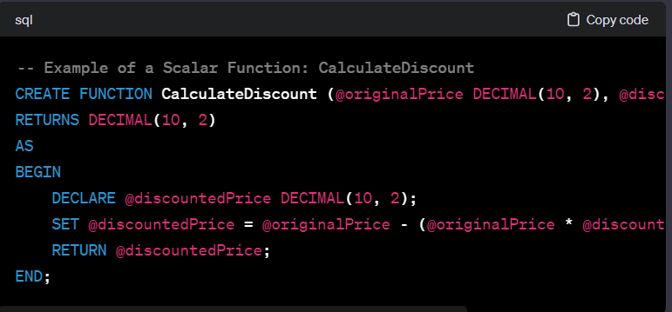

User-defined functions (UDFs) in SQL are custom functions created by users to perform specific tasks. These functions can encapsulate a set of SQL statements and can be invoked like built-in functions. SQL supports two types of user-defined functions: scalar functions and table-valued functions.

**Scalar Function Example:**

A scalar function returns a single value, and it can be used in SQL queries wherever an expression can be used.

In this example, the function **CalculateDiscount** takes two parameters (**@originalPrice** and **@discountPercentage**) and returns the discounted price. Users can use this function in a SELECT statement or other SQL operations.

**Purpose of the Scalar Function:**

The purpose of the **CalculateDiscount** function is to encapsulate the logic for calculating the discounted price based on the original price and a discount percentage. This encapsulation promotes code reuse and maintainability, as the discount calculation logic is centralized in the function.

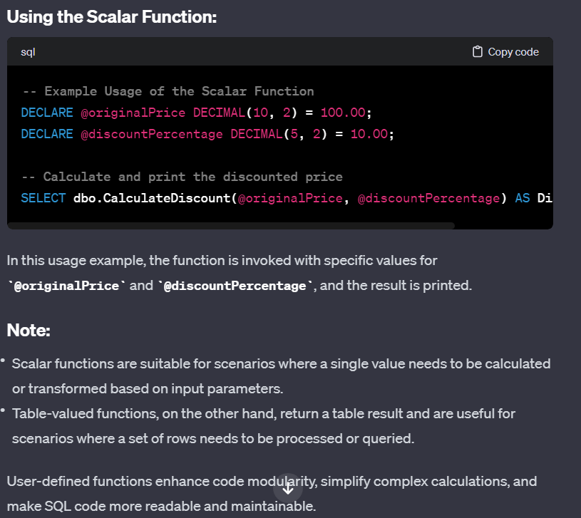

1. Differentiate between scalar functions and table-valued functions in SQL. Offer an example of each type of function and clarify their purposes.

**ANS:**

**TAB:**

**Purpos**e:

* Table-valued functions return a table result set. They can be used to encapsulate complex logic that involves multiple rows and columns.

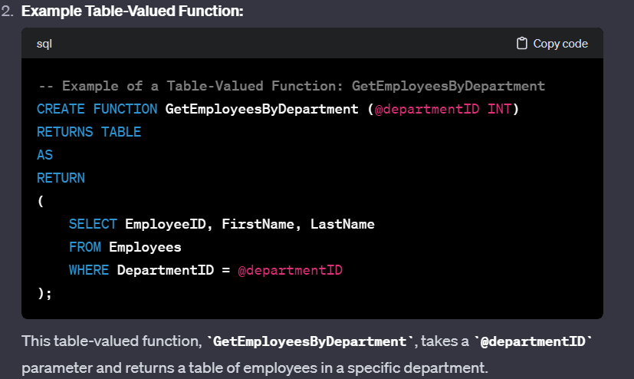

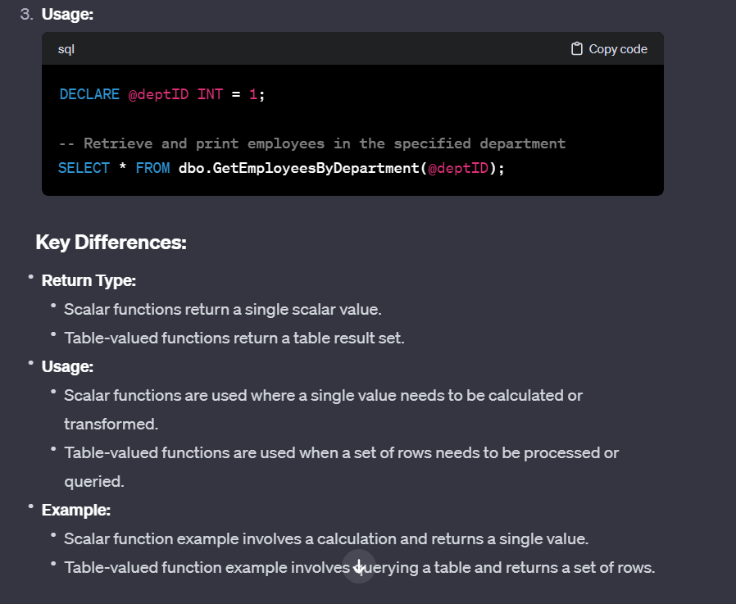

1. Explore the MongoDB Aggregation Framework in detail, highlighting its stages and their functions. Discuss the benefits of using the aggregation framework for data processing in MongoDB.

**ANS:**

The MongoDB Aggregation Framework is a powerful tool for processing and transforming data within MongoDB. It provides a flexible and expressive way to perform data aggregation operations, such as filtering, grouping, sorting, and projecting, on documents stored in MongoDB collections. The aggregation framework is particularly useful for complex data processing tasks and analytics.

**Key Concepts:**

1. **Pipeline:**
   * The aggregation framework operates using a pipeline paradigm. A pipeline consists of a sequence of stages, where each stage performs a specific operation on the data.
2. **Stages:**
   * Each stage in the pipeline represents a processing step. There are various stages available in the aggregation framework, and they can be combined to achieve complex transformations.

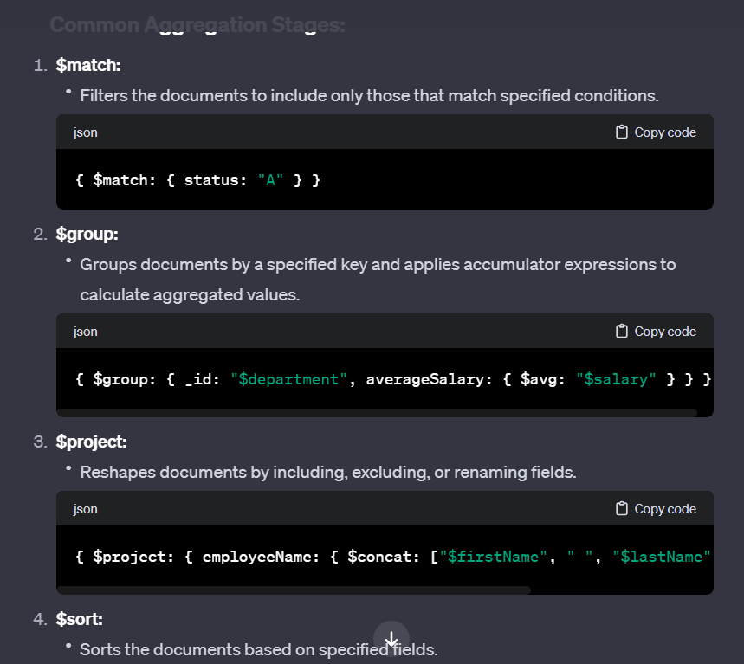

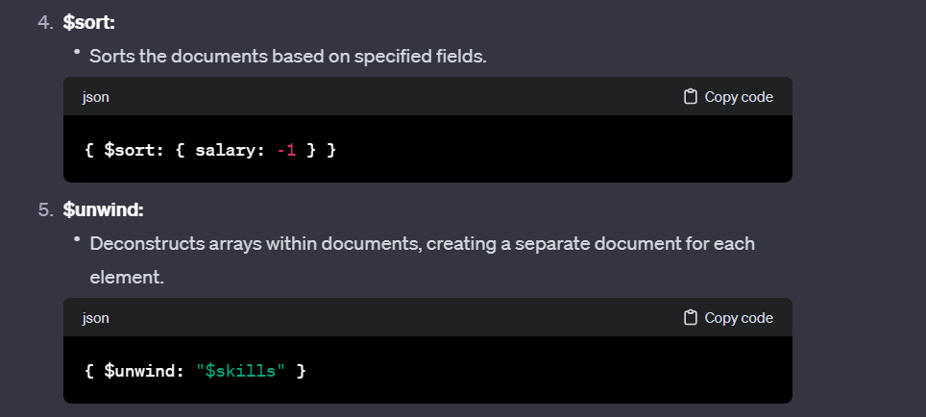

**Benefits of Aggregation Framework:**

1. **Flexibility:**
   * The aggregation framework offers a wide range of stages that can be combined in various ways, providing flexibility in designing complex data processing pipelines.
2. **Performance:**
   * Aggregation operations are performed close to the data, within the database engine, resulting in efficient processing and reduced data transfer.
3. **Expressiveness:**
   * The framework supports expressive syntax and a rich set of operators, making it easy to articulate complex data transformations and analytics.
4. **Scalability:**
   * Aggregation operations can take advantage of indexes, and the framework is designed to scale horizontally across distributed MongoDB clusters.
5. **Real-time Analytics:**
   * Enables real-time analytics by allowing dynamic computation of aggregated values on large datasets.
6. **Integration with Other Stages:**
   * Aggregation stages can be combined to perform multi-step processing, enabling the creation of sophisticated data pipelines.

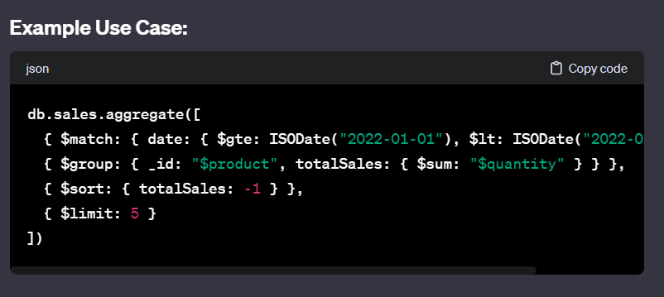

1. Describe the MongoDB Aggregation Framework and its key components. How does it differ from traditional SQL query operations?

**ANS:**

The MongoDB Aggregation Framework is a powerful tool for data processing and transformation within MongoDB. It allows users to perform complex operations on data stored in MongoDB collections, facilitating tasks such as filtering, grouping, projecting, and computing aggregations. The Aggregation Framework operates using a pipeline model, where documents pass through a sequence of stages to undergo various transformations.

**Key Components of the MongoDB Aggregation Framework:**

1. **Pipeline:**
   * The aggregation pipeline is a series of stages, with each stage representing a specific operation on the data. Documents pass through these stages in sequence.
2. **Stages:**
   * Each stage in the pipeline performs a specific data processing operation. Common stages include **$match**, **$group**, **$project**, **$sort**, **$unwind**, and more.
3. **Operators:**
   * Operators are used within stages to perform specific actions. Examples include arithmetic operators (**$add**, **$subtract**), comparison operators (**$eq**, **$gt**, **$lt**), array operators (**$push**, **$unwind**), and more.

Photo form above example:

In this example:

* The **$match** stage filters documents with a date within a specified range.
* The **$group** stage groups the filtered documents by product and calculates the total sales quantity for each product.
* The **$sort** stage sorts the results based on total sales in descending order.
* The **$limit** stage restricts the output to the top 5 products.

**Differences from Traditional SQL Query Operations:**

1. **Flexibility:**
   * MongoDB's Aggregation Framework offers more flexibility due to its ability to handle semi-structured and nested data. Traditional SQL queries may struggle with such data models.
2. **Document-Oriented Model:**
   * MongoDB's Aggregation Framework operates on BSON documents, allowing it to work seamlessly with MongoDB's document-oriented data model. Traditional SQL queries operate on tabular data.
3. **Expressiveness:**
   * The Aggregation Framework provides expressive and concise syntax for data transformations, making it suitable for complex analytical tasks. SQL queries can be verbose for similar operations.
4. **Nested Arrays:**
   * MongoDB's Aggregation Framework has stages like **$unwind** to handle nested arrays efficiently. Traditional SQL queries might require more complex operations for such scenarios.
5. **Index Utilization:**
   * Aggregation operations in MongoDB can take advantage of indexes, optimizing query performance. Traditional SQL queries may have different considerations for index utilization.
6. **Distributed Processing:**
   * MongoDB's Aggregation Framework is designed to work efficiently in distributed environments, making it suitable for horizontal scaling. Traditional SQL databases might rely more on vertical scaling.
7. **Real-time Analytics:**
   * The Aggregation Framework is well-suited for real-time analytics, allowing dynamic computation of aggregated values on large datasets. Traditional SQL databases may require additional tools for similar tasks.
8. Create a MongoDB aggregation pipeline to find the highest and lowest salaries for employees in a collection. Include appropriate labels for the results.

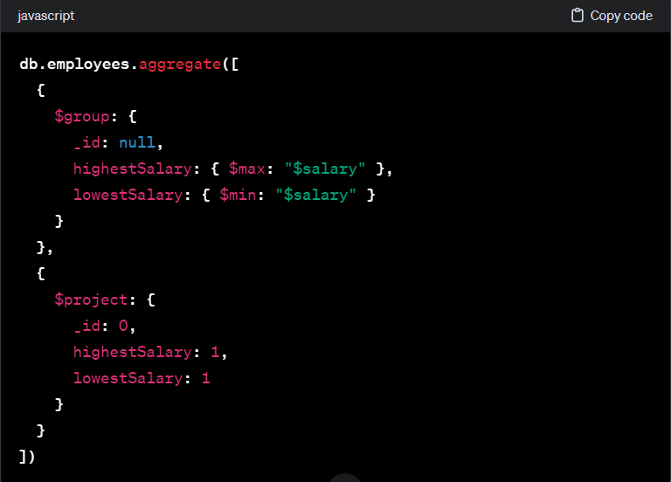

1. Provide an example of a MongoDB aggregation pipeline that demonstrates grouping, sorting, and projecting data.

**ANS:** Certainly! Let's consider a scenario where we have a collection named **sales** with documents representing sales transactions. Each document has fields like **product**, **quantity**, and **amount**. The example pipeline will group the data by product, calculate the total quantity and total amount for each product, sort the results by total quantity in descending order, and then project only the relevant fields:

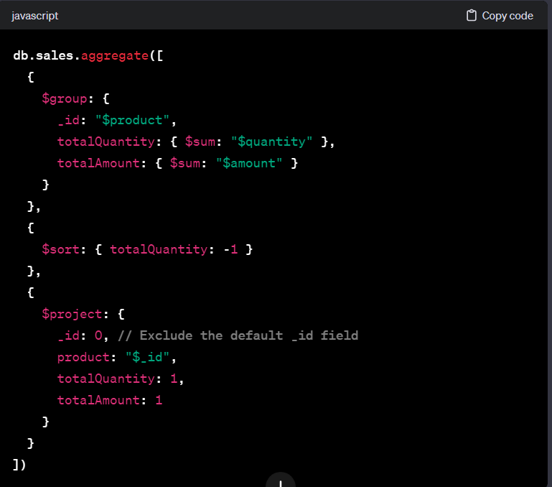

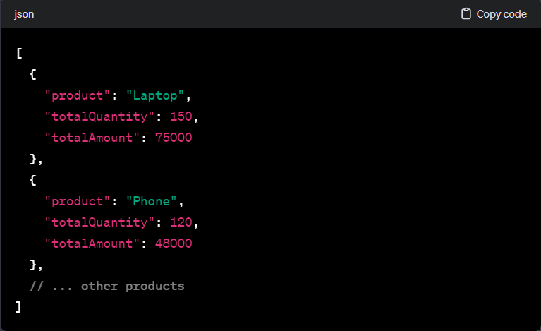

1. Define the concept of functional dependencies in database normalization. Explain how functional dependencies are used to determine candidate keys.

**ANS:**

Functional dependencies are a fundamental concept in the normalization process of relational databases. A functional dependency is a relationship between two sets of attributes in a relation, where knowing the values of one set of attributes uniquely determines the values of another set of attributes.

In the context of database normalization, functional dependencies play a crucial role in determining candidate keys and ensuring that a database schema is free from undesirable redundancies and anomalies.

Here are some key terms related to functional dependencies:

1. **Determinant:**
   * In a functional dependency A → B, A is called the determinant. It uniquely determines the values of B.
2. **Dependent:**
   * B is called the dependent. Its values are determined by the values of A.

**Determining Candidate Keys:**

Functional dependencies are used to identify candidate keys, which are minimal sets of attributes that can uniquely identify each tuple in a relation. The process involves identifying attributes that functionally determine all other attributes in the relation.

Consider a relation R with attributes A, B, C, and D. The functional dependencies could be expressed as:

* A → B (A uniquely determines B)
* BC → D (BC together uniquely determines D)
* D → A (D uniquely determines A)

To determine candidate keys:

1. **Closure of Attributes:**
   * Find the closure of each attribute set. The closure of an attribute set is the set of all attributes that can be functionally determined by that set.
2. **Superkeys:**
   * Identify superkeys, which are sets of attributes whose closure includes all attributes in the relation. Superkeys may contain redundant attributes.
3. **Candidate Keys:**
   * From superkeys, identify candidate keys by removing redundant attributes. A candidate key is a minimal superkey.
4. **Normalization:**
   * Use the identified candidate keys to normalize the relation and remove redundancy.

**Example:**

Consider a relation with attributes {A, B, C} and functional dependencies:

* A → B
* BC → A

The closure of {A} is {A, B}, and the closure of {BC} is {A, B, C}. Both {A} and {BC} are superkeys. However, {A} is a candidate key because it is minimal (removing any attribute would break uniqueness).

1. Discuss the factors that influence the choice between a clustered and non-clustered index in a database. Provide specific use cases for each type of index.

**ANS:**

The choice between a clustered and non-clustered index in a database is influenced by various factors, and each type has its own strengths and use cases. Let's discuss the factors and provide specific use cases for each type of index:

**Factors Influencing the Choice:**

1. **Data Retrieval Patterns:**
   * **Clustered Index:** Suitable for tables where there is a natural order or where the primary key is frequently used in queries for range searches.
   * **Non-Clustered Index:** Appropriate when the queries involve columns other than the primary key or when there are frequent updates.
2. **Table Size:**
   * **Clustered Index:** Effective for smaller tables as it organizes the data pages physically.
   * **Non-Clustered Index:** Suitable for larger tables as it doesn't affect the physical order of data pages.
3. **Insert, Update, and Delete Operations:**
   * **Clustered Index:** May result in higher costs for insert, update, or delete operations as the physical order of data pages might be affected.
   * **Non-Clustered Index:** Generally has lower impact on insert, update, or delete operations.
4. **Data Modification Patterns:**
   * **Clustered Index:** Appropriate when the data is relatively static or there are more read operations compared to write operations.
   * **Non-Clustered Index:** Suitable when there are frequent data modifications, as it imposes less overhead on these operations.
5. **Number of Index Columns:**
   * **Clustered Index:** Typically involves only one index per table, which is usually the primary key.
   * **Non-Clustered Index:** Can involve multiple indexes on different columns.

**Specific Use Cases:**

1. **Clustered Index:**
   * Use for primary key columns that are frequently used in range queries.
   * Use when the table is relatively small, and data retrieval performance is crucial.
   * Use when the table has a natural order based on a specific column.
2. **Non-Clustered Index:**
   * Use for columns frequently involved in search conditions other than primary key searches.
   * Use when there are many write operations (inserts, updates, deletes) on the table.
   * Use when the table is large, and data retrieval is often based on non-primary key columns.

**Example Scenario:**

Consider a table of customer orders:

* **Clustered Index:** Use a clustered index on the primary key (order ID) if there are frequent range queries based on order ID, and the table is relatively small.
* **Non-Clustered Index:** Use a non-clustered index on the customer ID if there are frequent queries based on customer ID, and the table undergoes frequent insert/update/delete operations.

1. Explain the role of database views in SQL. Provide an example of a view and describe a scenario where using a view is advantageous.

**ANS:**

**Role of Database Views in SQL:**

A database view in SQL is a virtual table based on the result of a SELECT query. Unlike physical tables, views do not store the actual data but provide a way to represent the data stored in one or more tables in a structured manner. Views are defined by SQL queries and can be used to simplify complex queries, encapsulate business logic, provide security, and present a customized perspective of the data.

**Example of a View:**

Let's consider a scenario where you have a database with tables **employees** and **departments**. You can create a view that combines information from these tables to present a consolidated view of employee details along with their department information.

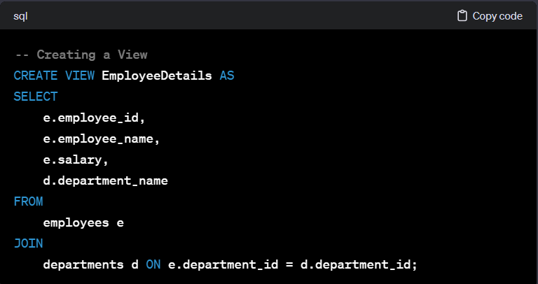

**Advantages of Using a View:**

1. **Simplified Queries:**
   * Views allow users to encapsulate complex SQL queries. Instead of writing the same complex query multiple times, a view can be created to simplify the query for users.
2. **Data Abstraction:**
   * Views provide a level of abstraction, allowing users to interact with a simplified representation of the data without needing to know the underlying table structures.
3. **Security:**
   * Views can be used to restrict access to certain columns or rows. Users can be granted access to views without giving them direct access to the underlying tables.
4. **Business Logic Encapsulation:**
   * Views enable the encapsulation of business logic in the database. For example, calculations or aggregations can be performed in the view definition.
5. **Customized Perspectives:**
   * Different views can be created for different user roles or applications, presenting customized perspectives of the data based on specific requirements.

**Scenario:**

Consider a scenario where an HR department needs to frequently retrieve information about employees and their departments. Instead of running complex JOIN queries each time, a view like **EmployeeDetails** can be created. This view simplifies the query for HR users, encapsulates the necessary JOIN logic, and ensures that they only see the relevant information without exposing the underlying database structure.

1. Explain the purpose and benefits of database constraints in ensuring data integrity. Provide examples of common constraints used in relational databases.

**ANS:**

Database constraints play a crucial role in maintaining data integrity within a relational database. They enforce rules and conditions on the data stored in tables, ensuring that it meets specific criteria and follows predefined relationships. The main purposes and benefits of database constraints include:

1. **Data Accuracy:**
   * Constraints prevent the insertion of incorrect or inconsistent data into tables, ensuring that the data accurately represents the real-world entities it is meant to model.
2. **Consistency:**
   * Constraints maintain consistency by enforcing rules across related tables. For example, a foreign key constraint ensures that values in a column match primary key values in another table.
3. **Prevention of Invalid Entries:**
   * Constraints prevent the insertion of values that do not adhere to specified rules, helping to avoid errors and maintain the validity of the database.
4. **Referential Integrity:**
   * Foreign key constraints maintain referential integrity by ensuring that relationships between tables are valid. This prevents orphaned records and maintains the integrity of relationships.
5. **Enforcement of Business Rules:**
   * Constraints allow the enforcement of business rules at the database level. For example, a CHECK constraint can enforce rules related to valid ranges or formats for data.
6. **Security:**
   * Constraints contribute to data security by preventing unauthorized or unintended changes to the data. They restrict actions that could compromise the integrity of the database.

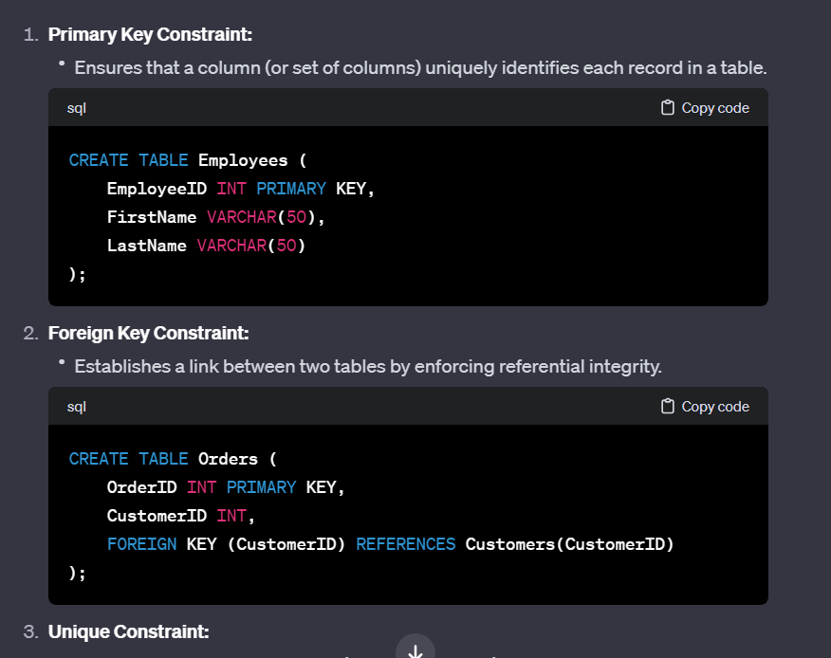

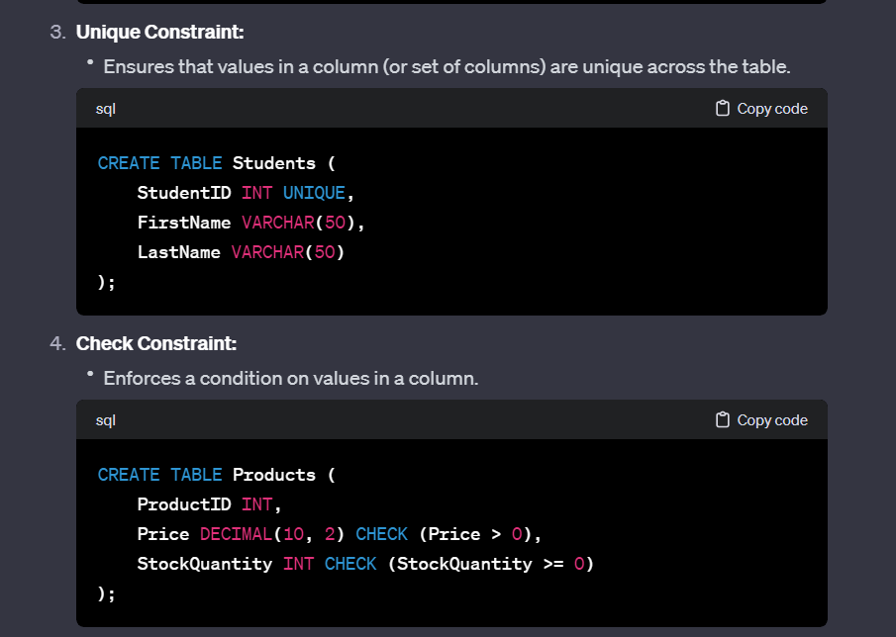

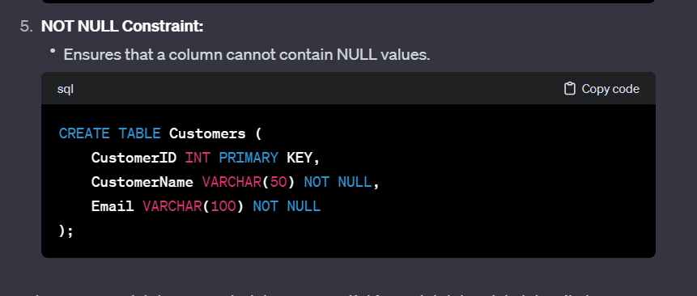

1. Describe the purpose and characteristics of NoSQL databases. Provide examples of NoSQL database types and explain when it's appropriate to use them in data storage and retrieval.

**ANS:**

**Purpose and Characteristics of NoSQL Databases:**

**Purpose:** NoSQL databases, or "Not Only SQL" databases, are designed to address specific challenges that arise in the era of big data, real-time applications, and diverse data models. The purpose of NoSQL databases is to provide flexible, scalable, and high-performance solutions for handling large volumes of unstructured or semi-structured data. They are particularly well-suited for use cases where traditional relational databases may face limitations.

**Characteristics:**

1. **Schema Flexibility:**
   * NoSQL databases offer schema flexibility, allowing developers to work with data models that may evolve over time. Unlike traditional relational databases, they do not require a predefined schema.
2. **Scalability:**
   * NoSQL databases are designed for horizontal scalability, allowing them to handle large amounts of data and traffic by distributing data across multiple nodes or servers.
3. **High Performance:**
   * NoSQL databases are optimized for specific use cases, providing high performance for read and write operations. They are often designed to handle large-scale distributed data processing.
4. **No Fixed Relationships:**
   * Unlike relational databases that rely on predefined relationships, NoSQL databases can handle data with varying structures and may not enforce fixed relationships between tables.
5. **Data Models:**
   * NoSQL databases support various data models, including document-oriented, key-value, column-family, and graph databases. Each type is optimized for specific data storage and retrieval requirements.
6. **BASE (Basically Available, Soft state, Eventually consistent):**
   * NoSQL databases often follow the BASE consistency model, which prioritizes availability and fault tolerance over strict consistency. This is in contrast to the ACID properties of traditional relational databases.

**Examples of NoSQL Database Types:**

1. **Document-Oriented Databases:**
   * *Example:* MongoDB
   * **Use Case:** Storing and retrieving data in JSON-like documents, suitable for content management systems, catalogs, and real-time applications.
2. **Key-Value Stores:**
   * *Example:* Redis
   * **Use Case:** Caching, session storage, and scenarios where simple key-based access to data is required.
3. **Column-Family Stores:**
   * *Example:* Apache Cassandra
   * **Use Case:** Time-series data, data warehousing, and applications requiring fast write and read access.
4. **Graph Databases:**
   * *Example:* Neo4j
   * **Use Case:** Representing and querying relationships between entities in complex networks, such as social networks or fraud detection.
5. **Wide-Column Stores:**
   * *Example:* Apache HBase
   * **Use Case:** Storing and retrieving large amounts of data with high write and read throughput, suitable for big data applications.

**When to Use NoSQL Databases:**

* **Dynamic Schema Requirements:**
  + Use NoSQL when dealing with evolving or unpredictable data structures where a fixed schema is impractical.
* **Scalability Requirements:**
  + Choose NoSQL when scalability and distributed processing are essential for handling growing data volumes and increasing user loads.
* **Specific Use Cases:**
  + Opt for NoSQL when dealing with use cases such as real-time analytics, content management, recommendation engines, and applications requiring high-performance access to diverse data types.

1. What is the primary purpose of a database management system (DBMS), and how does it differ from a traditional file system for data storage?

**ANS:**

The primary purpose of a Database Management System (DBMS) is to efficiently and securely manage, organize, store, retrieve, and manipulate data in a structured and systematic manner. DBMS serves as an interface between the application programs and the physical data storage, providing a centralized and controlled environment for managing databases.

**Key Functions of a DBMS:**

1. **Data Definition:**
   * Define the structure and organization of data through schema definition, specifying tables, relationships, and constraints.
2. **Data Manipulation:**
   * Perform operations on the data, including insertion, retrieval, updating, and deletion, using query languages like SQL (Structured Query Language).
3. **Data Integrity:**
   * Enforce data integrity constraints, ensuring the accuracy, consistency, and reliability of the data stored in the database.
4. **Concurrency Control:**
   * Manage concurrent access to the database by multiple users to ensure data consistency and prevent conflicts.
5. **Security:**
   * Implement access controls and authentication mechanisms to protect the database from unauthorized access and ensure data privacy.
6. **Data Recovery and Backup:**
   * Provide mechanisms for data backup, recovery, and restoration in case of system failures or data corruption.
7. **Query Optimization:**
   * Optimize queries and transactions to enhance the performance and efficiency of data retrieval and manipulation.
8. **Transaction Management:**
   * Ensure the atomicity, consistency, isolation, and durability (ACID properties) of transactions for maintaining data integrity.

**Differences from Traditional File System:**

1. **Data Structure:**
   * DBMS uses a structured and organized approach with tables, relationships, and constraints, while a file system relies on flat files and folders.
2. **Data Independence:**
   * DBMS provides a higher level of abstraction, allowing changes to the data structure without affecting application programs. File systems may require program modifications for structural changes.
3. **Data Redundancy:**
   * DBMS minimizes data redundancy by normalizing data and establishing relationships, reducing the chances of inconsistent data. File systems may lead to duplicated and inconsistent data.
4. **Data Integrity and Security:**
   * DBMS enforces integrity constraints and security features, ensuring data accuracy and protection. File systems may lack built-in mechanisms for integrity and security.
5. **Query Language:**
   * DBMS uses a standardized query language (SQL) for interacting with data. File systems often rely on programming languages or custom methods for data retrieval.
6. **Concurrency Control:**
   * DBMS manages concurrent access to data, preventing conflicts and ensuring consistency. File systems may lack built-in concurrency control mechanisms.
7. **Scalability:**
   * DBMS is designed for scalability, handling large volumes of data and users. File systems may face challenges in scaling for complex data scenarios.